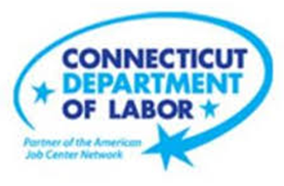

**NEW WEEKLY JOB POSTINGS FROM   
HELP WANTED ONLINE  
Office of Research**

**Week Ending April 2nd, 2022: Connecticut New Ads Up Over the Week, Outpacing US growth**WETHERSFIELD, April 8th, 2022 – During the week ending April 2nd, 2022, there were 9,146 new postings, up 628 new ads or +7.3% over the week. Connecticut’s 7.3% growth slightly outpaces the 6.6% growth nationally and was driven by increases in Accommodation & Food Services, Educational Services, and Manufacturing. These three industries grew by a combined 532 new ads. Industries that tempered overall growth with declines include Health Care & Social Assistance, Real Estate, and Transpiration & Warehousing, which respectively fell by -197, -117, and -74 new ads. Employers that added the most ads over the week include The Home Depot (+84 new ads), Masonicaire Corp. (+70 new ads), and Raytheon (+64 new ads). The total count of weekly job ads for the week ending April 2nd is 31% above corresponding levels from a year ago.

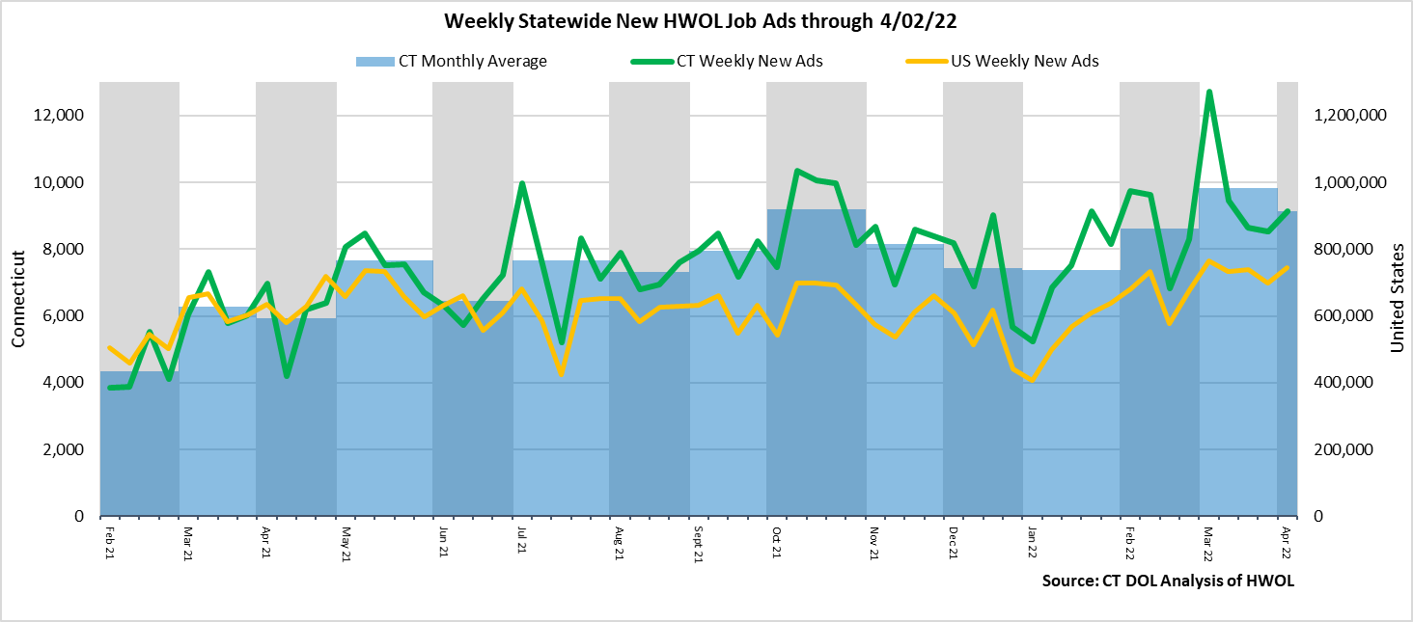  
**Industries** with the most new postings include Health Care & Social Assistance, Finance & Insurance, and Retail Trade.

**Occupations** with the most new postings include Registered Nurses, Retail Salespersons, and Wholesale & Manufacturing Sales Representatives.

**Employers** with the most new postings include Raytheon, UnitedHealth Group, and Yale-New Haven Health System.

**The three industries with the most new job postings where:**

* **Health Care & Social Assistance** (1,798 new postings, -10% over the week)
* **Finance & Insurance** (792 new postings, -1% over the week)
* **Retail Trade** (781 new postings, +11% over the week)

   
 During the week ending April 2nd, the total growth of 628 new ads is the net result of change within eleven increasing and ten decreasing industries. The eleven increasing industries grew by a combined 1,192 new ads, with most of that occurring in Accommodations & Food Services (+212 new ads) and Educational Services (+178 new ads). The ten decreasing industries fell by a combined 564 new ads, with the largest drops occurring in Healthcare & Social Assistance (-197 new ads) and Real Estate (-117 new ads). All but two industries had over the week percent shifts of 10% or more, one of the largest increases occurred in Arts, Entertainment, & Recreation (+87% or +59 new ads) and the largest decrease occurred in Utilities (-65% or -64 new ads).   
  
 For more information on total job ads by industry for Connecticut and its labor market areas, see the monthly report available here: <https://www1.ctdol.state.ct.us/lmi/hwol.asp>

**New Job Postings by Occupation** 

**The occupations with the most new postings were:**

* Registered Nurses (399 new postings, -41% over the week)
* Retail Salespersons (313 new postings, +55% over the week)
* Sales Representatives, Wholesale and Manufacturing (216 new postings, +27% over the week)

**Employers with the Most New Job Postings**

Employers with the most new job postings during the week were mostly in Healthcare, Finance & Insurance, and Retail Trade. The 25 employers shown above account for 16 percent of all new ads. Among the top 25 employers, 18 had over the week ad increases and 7 had decreases. The largest increasing employer over the week was The Home Depot (+84 new ads) and the largest decreasing employer was Hartford Healthcare (-311 new ads). Over four weeks, 20 of 25 employers shown above had increases and 5 had decreases. The largest of each was The Home Depot (+89 new ads and Hartford Healthcare (-1,906 new ads)

**What is HWOL?**The **Conference Board Help Wanted Online**® Data Series (HWOL) measures the number of new, first-time Online job postings and jobs reposted from the previous month for over 16,000 Internet job boards, corporate boards and smaller job sites that serve niche markets and smaller geographic areas. To view more HWOL data, go to: <https://www1.ctdol.state.ct.us/lmi/hwol.asp>